**Carmen yareli Muñoz Vargas**

* Numero: 9981634064
* Mujer
* 28 años
* Talla 1.57
* 86 kg
* Circunferencia cintura cadera 102cm
* PA 120/80
* IMC= 29.7 Dx= sobrepeso

GEB: 1631.5

AF: 20% = 326.3

ETA: 10% =163.1

Total: 2120.9

Kcal 1800

|  |  |  |  |
| --- | --- | --- | --- |
| NUTRIMENTO | % | Gramos | kcal |
| CHO | 60 | 270 | 1080 |
| LIP | 25 | 50 | 450 |
| PROT | 15 | 67.5 | 270 |

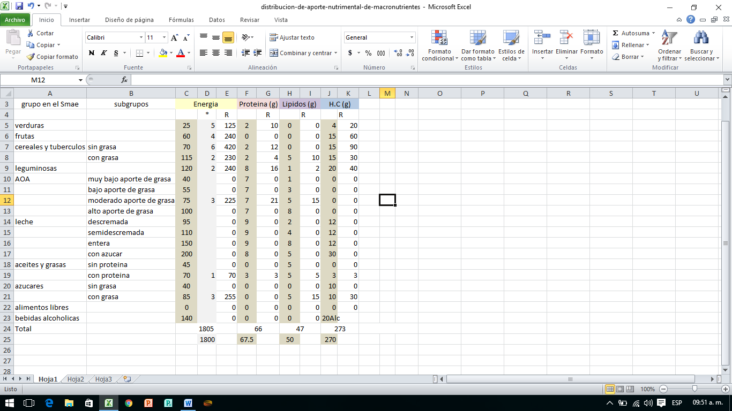

**Rebeca Aguilar Perez**

* Expediente 461
* Numero: 9981576385
* 42 años
* 73.3kg
* Talla: 152cm
* IMC= 31.7 Dx= Obesidad tipo 1
* 120/80
* 119mg/dl
* Col 221
* Trigl 226
* Creatinina .8

GEB = 1440.4

AF 20%= 288

ETA 10%= 144

Total= 1873.40

Kcal= 1500

|  |  |  |  |
| --- | --- | --- | --- |
| Macros | % | Gramos | Kcal |
| CHO | 60 | 225 | 900 |
| LIP | 20 | 33.3 | 300 |
| PROT | 20 | 75 | 300 |

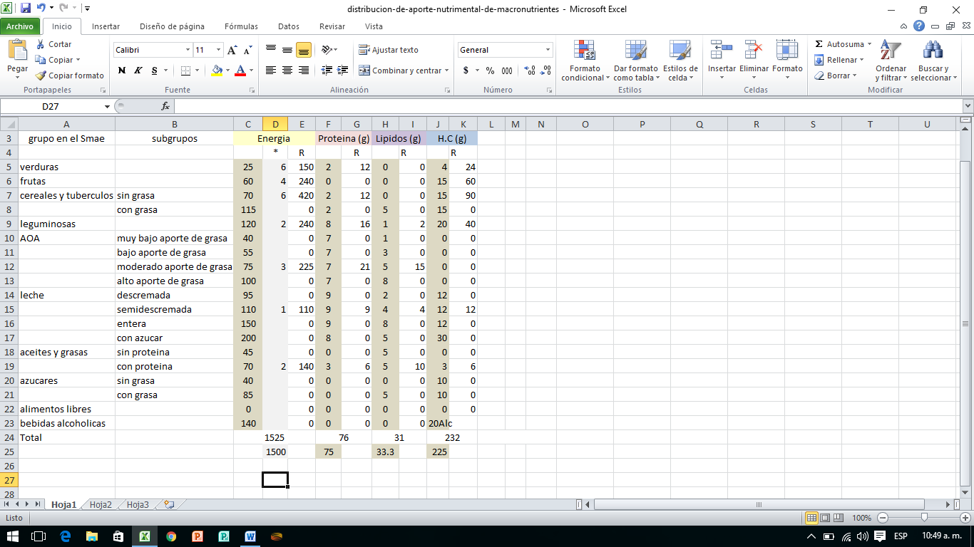

**Martinez Martinez Maria Beatriz**

* Exp. 3368
* 55 años
* 88kg
* Talla 151 cm
* CC 104
* 140/90
* 113mg/ dl
* IMC: 38.5 Dx: Obesidad tipo 2

GEB = 1518.3

AF 20%=303.6

ETA 10%= 151.8

Total= 1973.7

Kcal= 1600

|  |  |  |  |
| --- | --- | --- | --- |
| Macros | % | Gramos | Kcal |
| CHO | 55 | 220 | 880 |
| LIP | 30 | 53.3 | 480 |
| PROT | 15% | 60 | 240 |

**Ingrid Monserrat Perez Perez**

Exp. 1004

REVISIÓN DE ESTADO NUTRICIONAL 6 DE FEBRERO

Desnutrición moderada

16.5 kg

4 años 11 meses

Número: 9981195833

Kcal=1325

|  |  |  |  |
| --- | --- | --- | --- |
| Macros | % | gramos | Kcal |
| CHO | 60 | 198.7 | 795 |
| LIP | 25 | 36.8 | 331.2 |
| PROT | 15 | 49.6 | 198.7 |

**Gilberto Berron Herrera**

Colesterol alto

33 años

Talla 168

103.8 kg

CC 117

120/ 100

92mg /dl

GEB=2110.6

AF 20%=422.12

ETA 10%=211

Total= 2743

Kcal= 2243

|  |  |  |  |
| --- | --- | --- | --- |
| Macros | % | gramos | Kcal |
| CHO | 60 | 336.4 | 1345 |
| LIP | 20 | 49.8 | 448.6 |
| PROT | 20 | 112.15 | 448.6 |

**Florencia Moo Chuc**

S.P 231312114

Número: 9981101188

* 50 años
* Talla 148cm
* 73.3 kg
* C.C 98
* IMC= 33.46
* 150/90
* 114mg/dl

GEB= 1395.6

AF 20%= 279.1

ETA 10%=139.5

Total= 1814.2

Kcal= 1500

|  |  |  |  |
| --- | --- | --- | --- |
| Macros | % | gramos | Kcal |
| CHO | 60 | 225 | 900 |
| LIP | 25 | 41.6 | 375 |
| PROT | 15 | 56.2 | 225 |

**Sandra Lopez Reyes**

S.P 2300301400100402

* Número: 9983178057
* 33 años
* 145cm
* 66.2 kg
* IMC: 31.4

GEB= 1401.7

AF 20%= 280.3

ETA 10%= 140.1

Total= 1822.1

Kcal= 1500

|  |  |  |  |
| --- | --- | --- | --- |
| Macros | % | gramos | Kcal |
| CHO | 60 | 225 | 900 |
| LIP | 25 | 41.6 | 375 |
| PROT | 15 | 56.2 | 225 |

**Balbina Montiel Machucho**

Exp. 1000

* Número= 9983298176
* 37 años
* 78.5 kg
* 151 cm
* IMC=34.4 Dx:
* 120/80
* 190 mg/dl

GEB= 1511.7

AF 20%= 302.3

ETA 10%=151.1

Total=1965.1

Kcal= 1600

|  |  |  |  |
| --- | --- | --- | --- |
| Macros | % | gramos | Kcal |
| CHO | 60 | 240 | 960 |
| LIP | 20 | 35.5 | 320 |
| PROT | 20 | 80 | 320 |

**Nelsy Muñoz Vargas**

Exp. 223

* Número: 9985780315
* 67.5kg
* Talla 153
* 31 años
* IMC= 28.8
* C.C 93
* 100/80
* 123 mg/dl

GEB= 1438.3

AF 20%=287.6

ETA 10%=143.8

Total= 1869.4

Kcal= 1500

|  |  |  |  |
| --- | --- | --- | --- |
| Macros | % | gramos | Kcal |
| CHO | 55 | 206 | 825 |
| LIP | 25 | 41.6 | 375 |
| PROT | 20 | 75 | 300 |